Project Development Phase
Model Performance Test
Date | 28 September 2026
Team ID | 6ab221d587602313e82c60c9
Project Name | Project - Import Data using Transform Maps (Spreadsheet)
Maximum Marks | 10 Marks

Model Performance Testing:
Project team shall fill the following information in model performance testing template.
S.No. | Parameter | Values | Screenshot
1. | Metrics | Import Metrics:  Total Rows Loaded (Import Set) -  Records Inserted - , Records Updated -  Records Skipped / Ignored -  Error Count -  Transform Result:  Transform History Status - , Success Rate - |   Load Data: Processed 4, inserts 4, errors 0    Transform History: Total 4, Inserts 2, Updates 2, Ignored 0, Skipped 0, Errors 0    Re-import of same sheet: Inserts 0, Updates 0, Ignored 4    Transform State: Complete, Completion code: Success
2. | Tune the Model | Coalesce Field Tuning (Employee ID / Email) -  Field Mapping & Transform Script (onBefore) -  Validation Method - Test load with sample rows, verify records in target table |   Coalesce = true on Employee ID    Field mapping: source to target fields  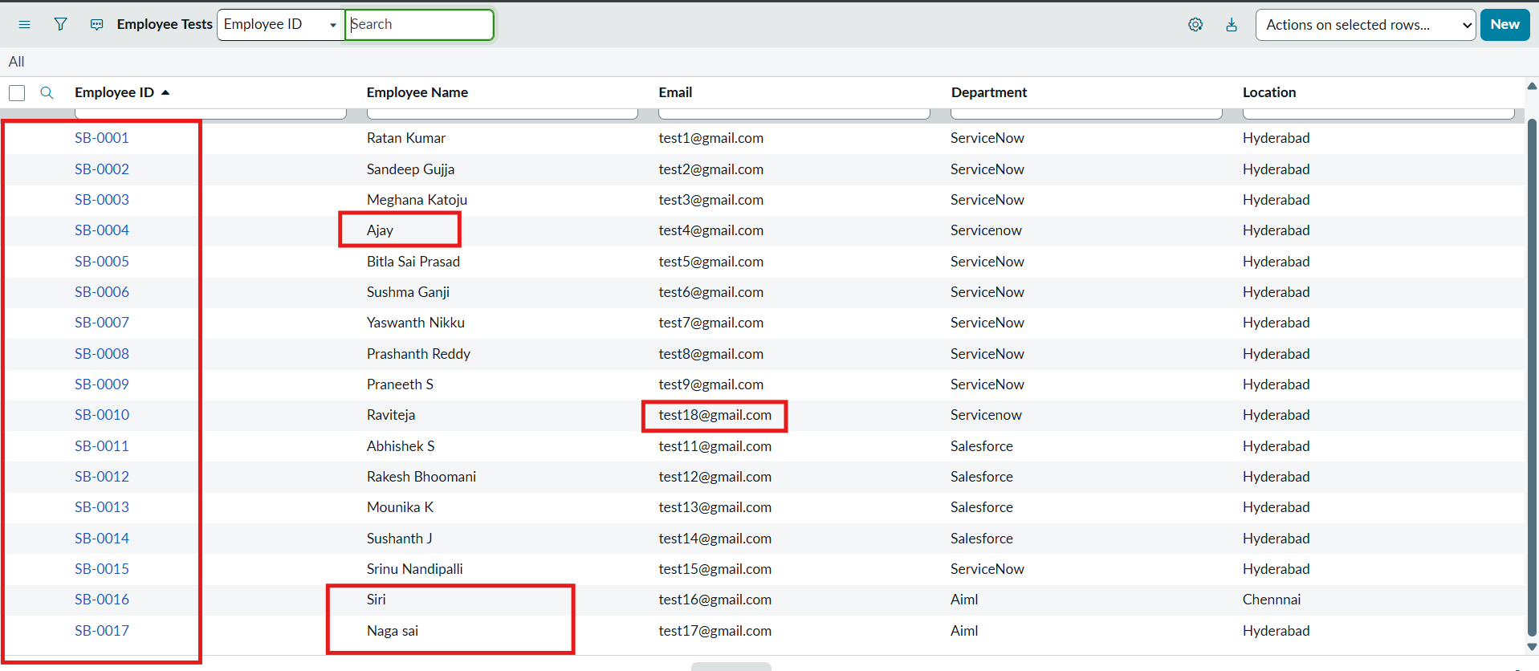  Target table check: rows updated / inserted

